Growth vs. light-capture in PhycoCyanin and PhycoErythrin-rich picocyanobacteria, across photic regimes and growth phases

Sylwia Śliwińska-Wilczewska1,2, Marta Konik3,4, Mireille Savoie1, Naaman Omar1, and Douglas A. Campbell1,✉

1 Department of Biology, Mount Allison University, 53 York St., Sackville NB, Canada, E4L 1C9  
2 Institute of Oceanography, University of Gdansk, 46 Pilsudskiego St, P81-378, Gdynia, Poland  
3 Department of Geography, University of Victoria, Victoria, BC V8P 5C2, Canada  
4 Institute of Oceanology, Polish Academy of Sciences, 81-712 Sopot, Poland

✉ Correspondence: [Douglas A. Campbell <[dcampbel@mta.ca](mailto:dcampbel@mta.ca)>](mailto:dcampbel@mta.ca)

# Supplementary material

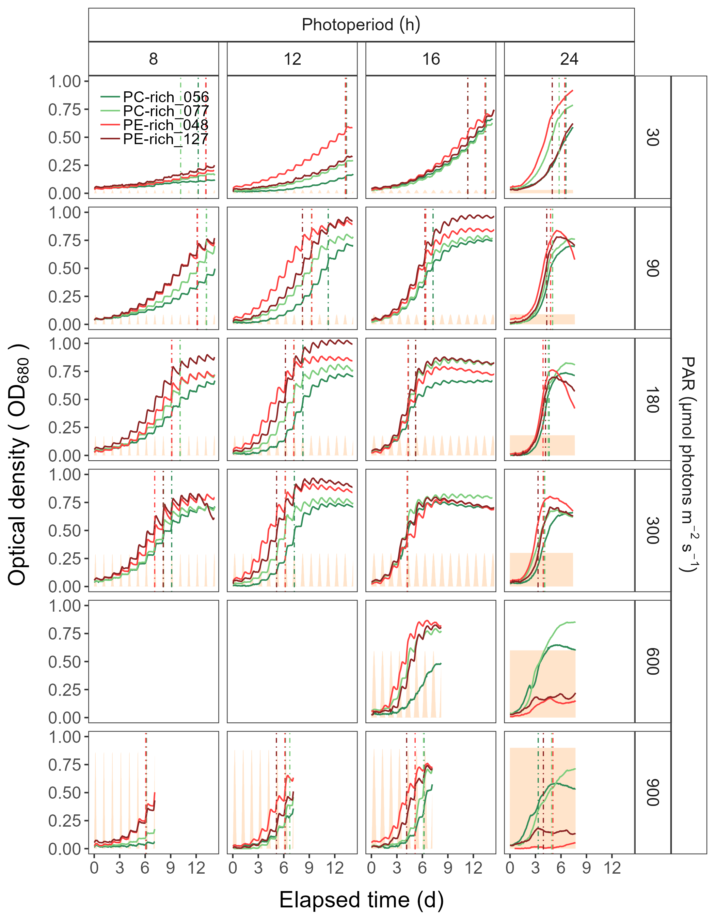

Figure 1: **Growth curves (tracked as OD680) vs. elapsed time (h).** Growth curves were estimated over 5-min intervals for two PhycoCyanin(PC)-rich cultures (056, 077) and two PhycoErythrin(PE)-rich cultures (048, 127) of *Synechococcus* sp. originating from the Baltic Sea. Cultures were grown at 30, 90, 180, 300, 600, or 900 peak PAR µmol photons m−2s−1; and photoperiods of 8, 12, 16, or 24 h. The vertical lines represent the time when the cultures (PC-rich_056; dark green, PC-rich_077; light green, PE-rich_048; light red, PE-rich_127; dark red) reached the maximum of the 1st derivative of OD680, or maximum absolute hourly growth (tMaxAHG), taken as an index of transition from exponential to pre-stationary growth phases. The orange area represents the photoperiods, with peak PAR x 1/1000 to scale to the Y axis.

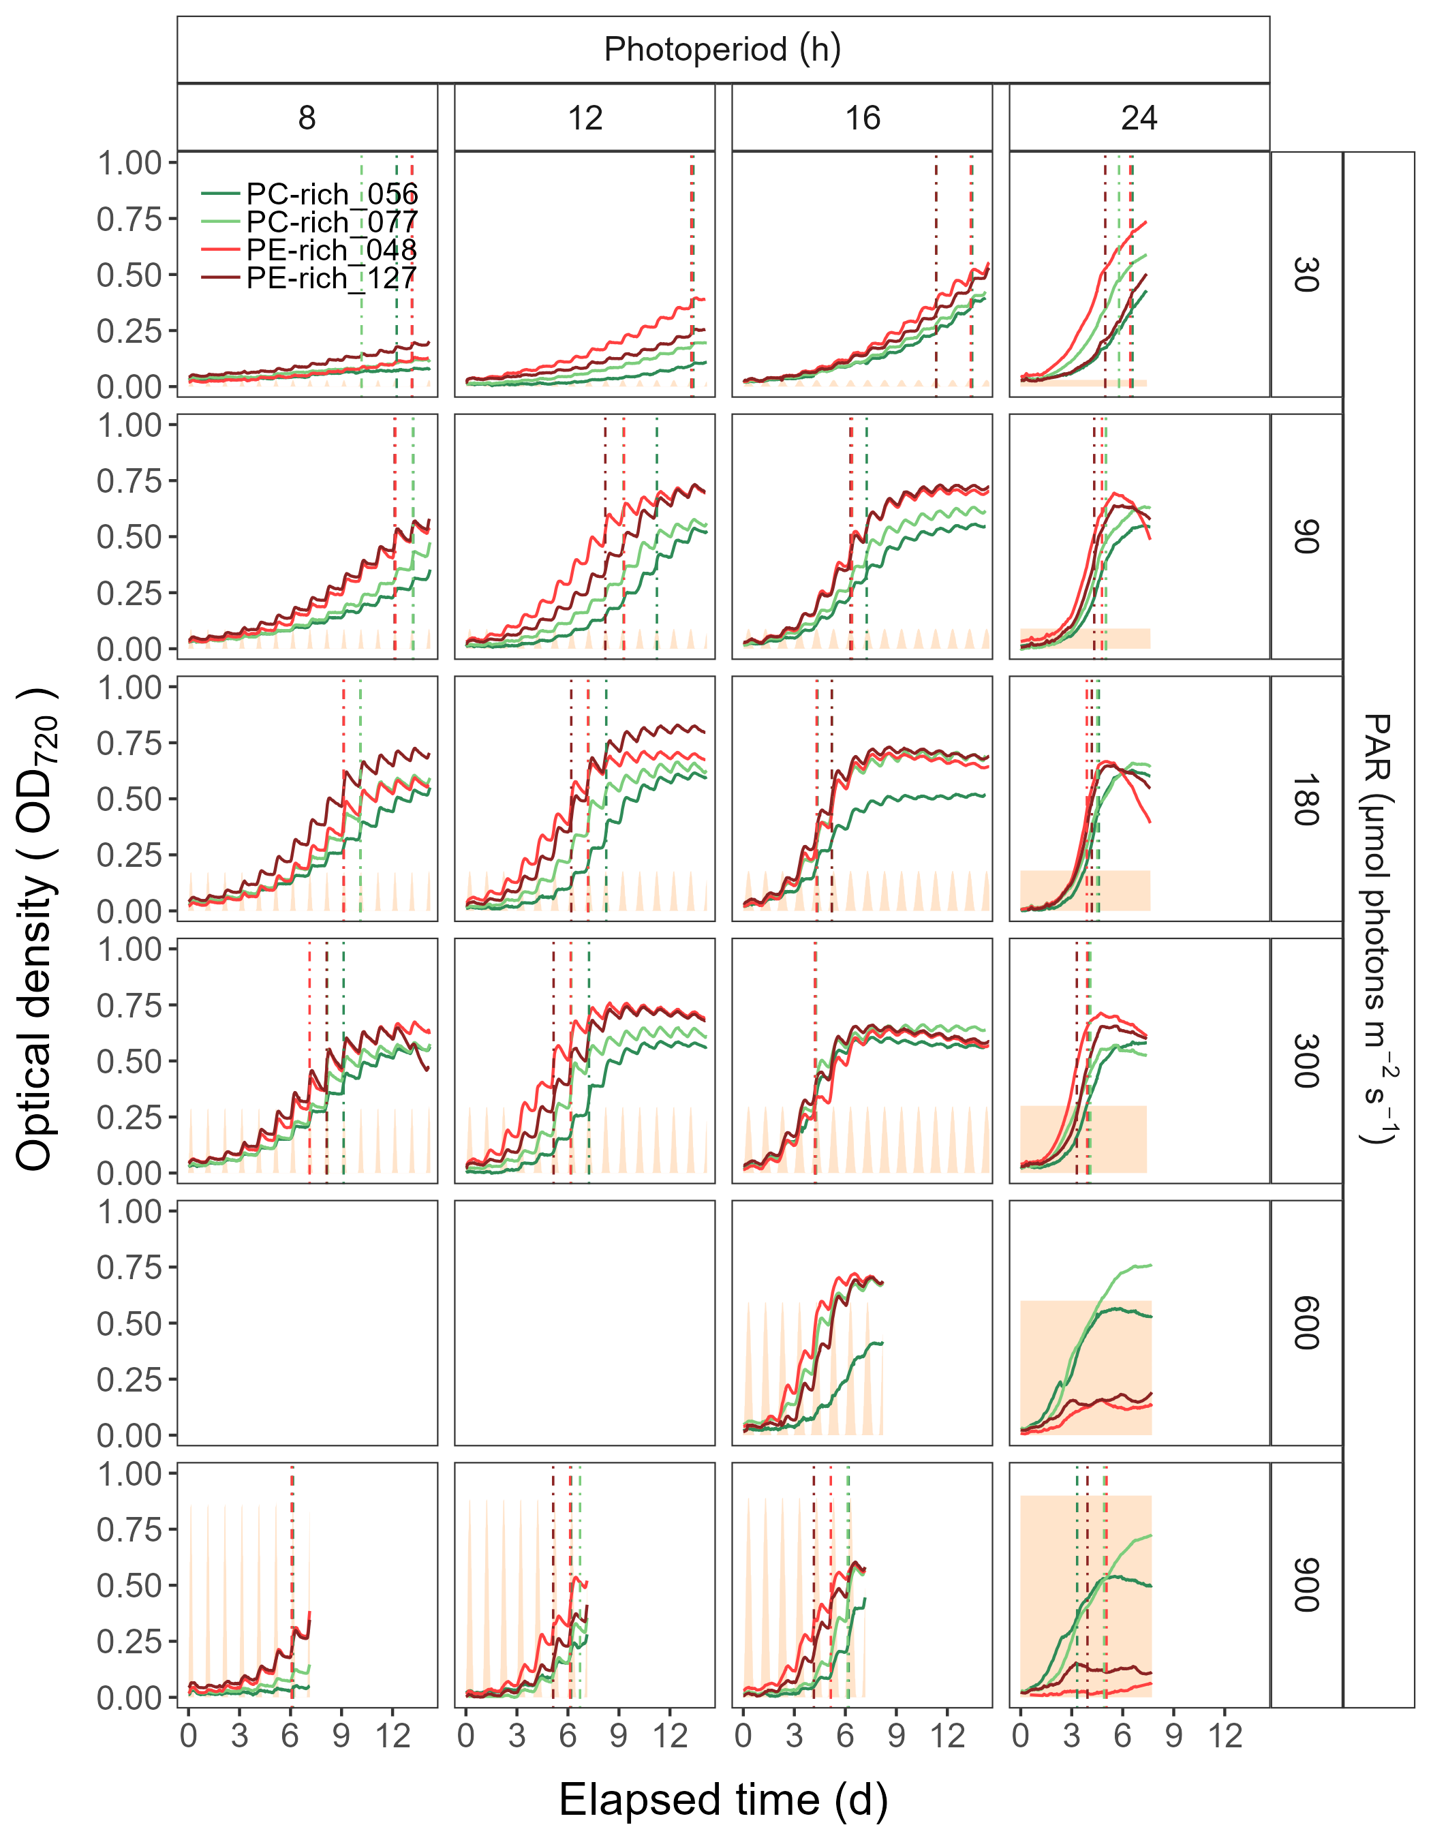

Figure 2: **Growth curves (tracked as OD720) vs. elapsed time (h).** Growth curves were estimated over 5-min intervals for two PhycoCyanin(PC)-rich cultures (056, 077) and two PhycoErythrin(PE)-rich cultures (048, 127) of *Synechococcus* sp. originating from the Baltic Sea. Cultures were grown at 30, 90, 180, 300, 600, or 900 peak PAR µmol photons m−2s−1; and photoperiods of 8, 12, 16, or 24 h. The vertical lines represent the time when the cultures (PC-rich_056; dark green, PC-rich_077; light green, PE-rich_048; light red, PE-rich_127; dark red) reached the maximum of the 1st derivative of OD680, or maximum absolute hourly growth (tMaxAHG), taken as an index of transition from exponential to pre-stationary growth phases. The orange area represents the photoperiods, with peak PAR x 1/1000 to scale to the Y axis.

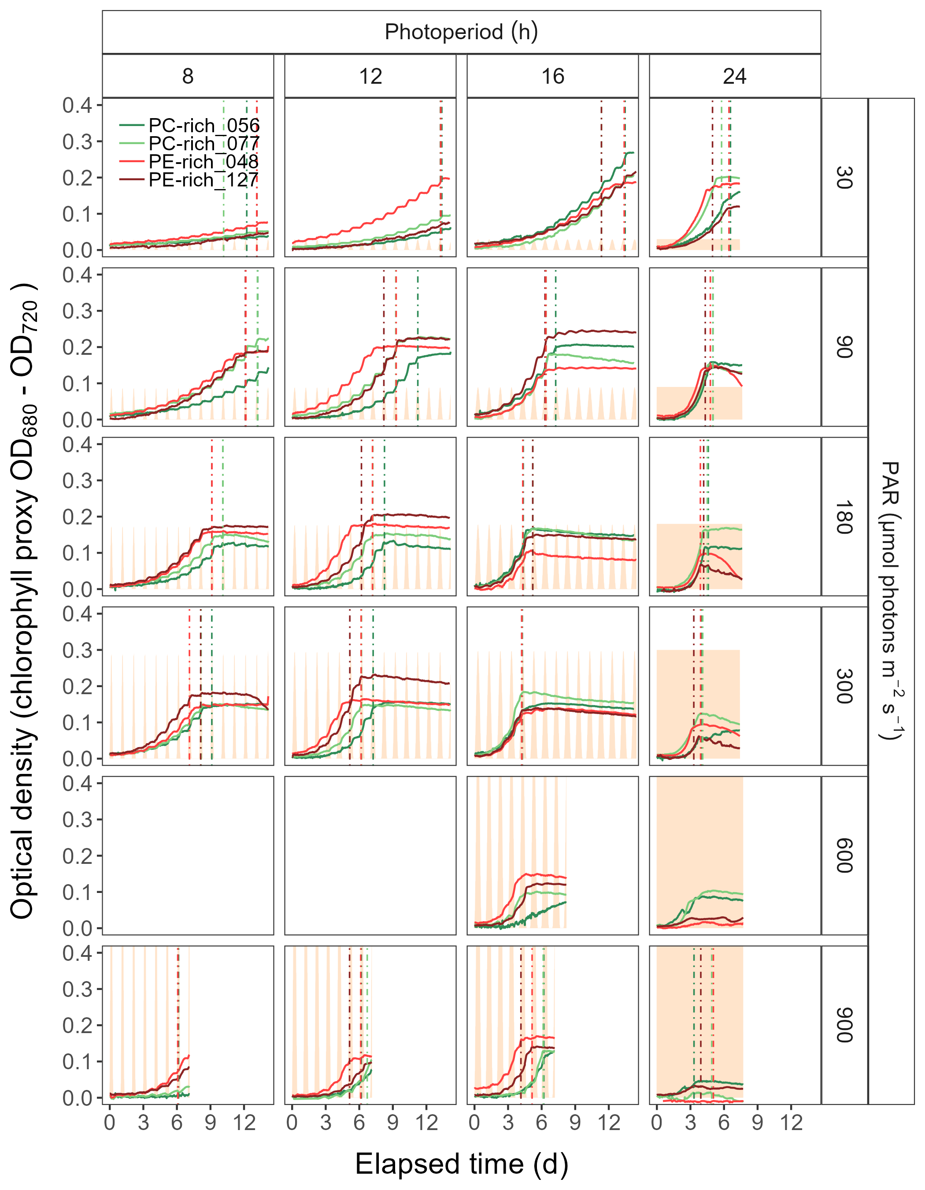

Figure 3: **Growth curves (tracked as chlorophyll proxy OD680-OD720; Δ OD) vs. elapsed time (h).** Growth curves were estimated over 5-min intervals for two PhycoCyanin(PC)-rich cultures (056, 077) and two PhycoErythrin(PE)-rich cultures (048, 127) of *Synechococcus* sp. originating from the Baltic Sea. Cultures were grown at 30, 90, 180, 300, 600, or 900 peak PAR µmol photons m−2s−1; and photoperiods of 8, 12, 16, or 24 h. The vertical lines represent the time when the cultures (PC-rich_056; dark green, PC-rich_077; light green, PE-rich_048; light red, PE-rich_127; dark red) reached the maximum of the 1st derivative of OD680, or maximum absolute hourly growth (tMaxAHG), taken as an index of transition from exponential to pre-stationary growth phases. The orange area represents the photoperiods, with peak PAR x 1/2000 to scale to the Y axis.

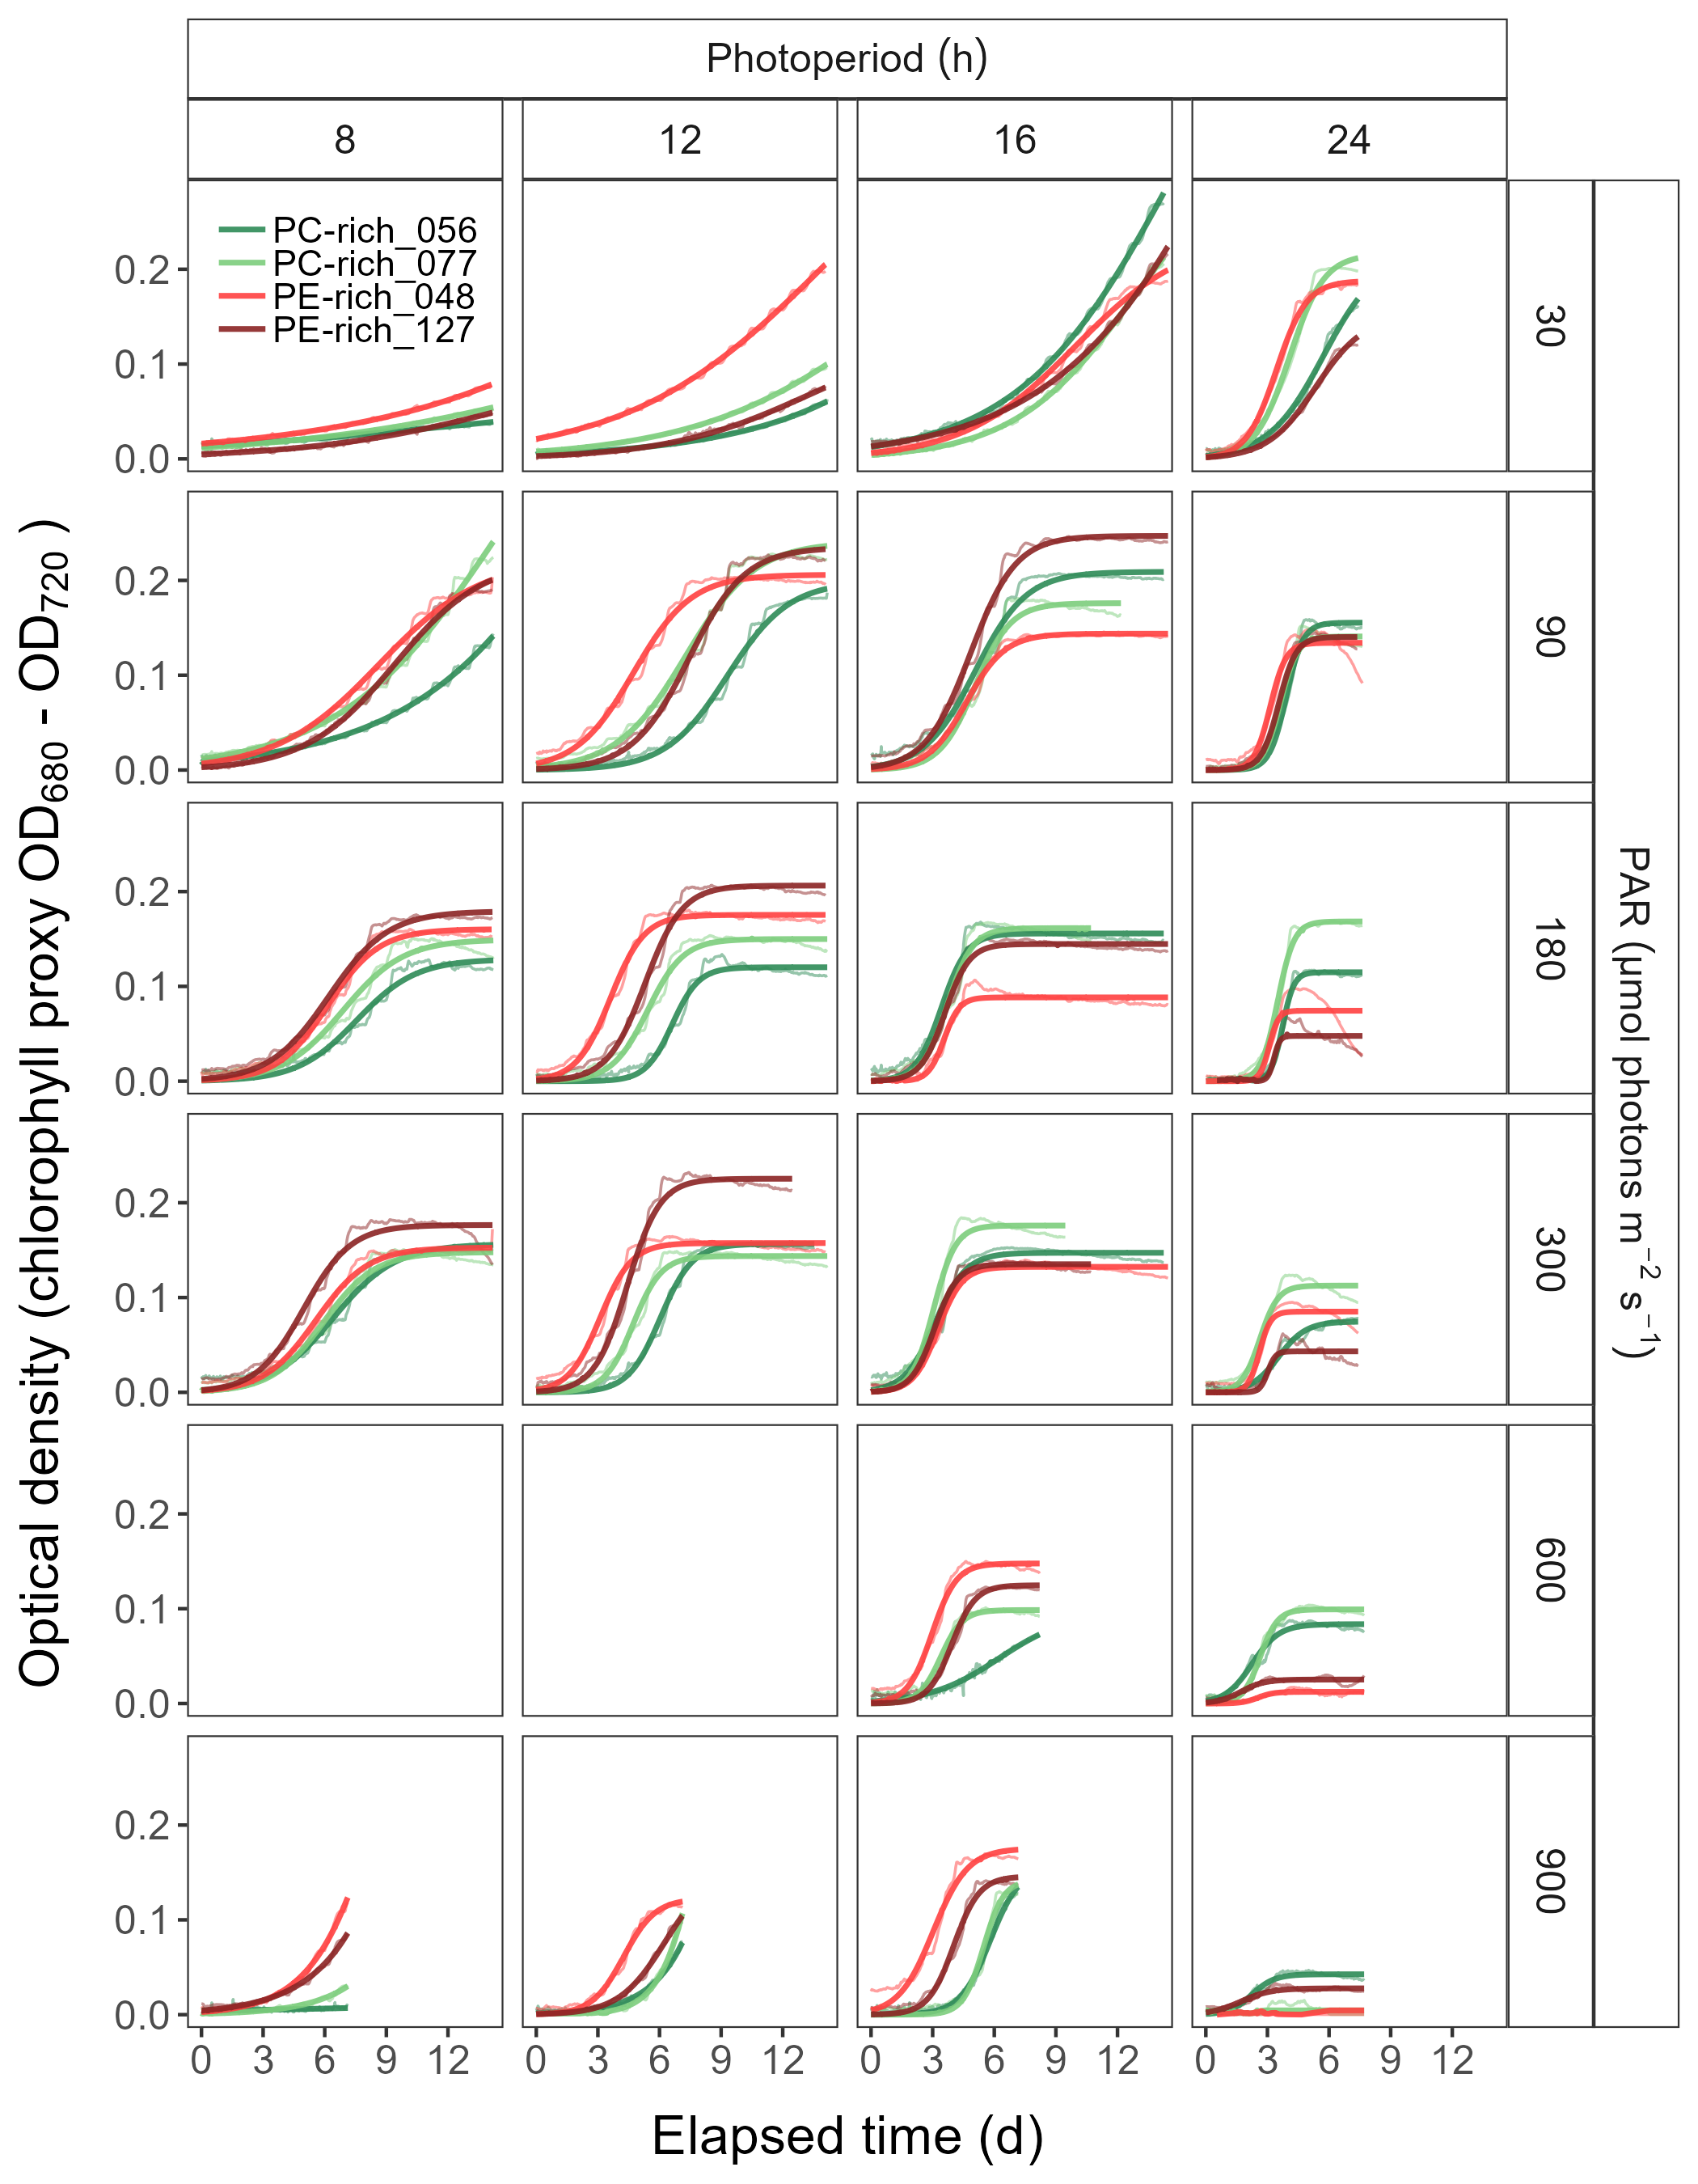

Figure 4: **Logistic fits of chlorophyll proxy OD680-OD720 (Δ OD) vs. elapsed time (h).** Logistic fits were estimated for two PhycoCyanin(PC)-rich cultures (056, 077) and two PhycoErythrin(PE)-rich cultures (048, 127) of *Synechococcus* sp. originating from the Baltic Sea. Cultures were grown at 30, 90, 180, 300, 600, or 900 peak PAR µmol photons m−2s−1; and photoperiods of 8, 12, 16, or 24 h. Growth curves (thin line) estimated over 5-min intervals for each strain were also presented (PC-rich_056; dark green, PC-rich_077; light green, PE-rich_048; light red, PE-rich_127; dark red).

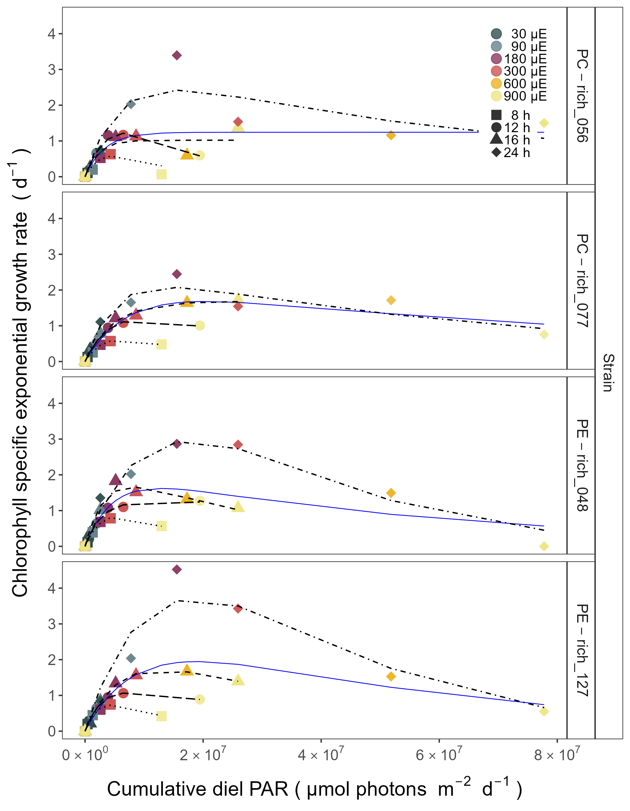

Figure 5: **Chlorophyll specific exponential growth rates (d−1) vs. cumulative diel PAR (µmol photons m−2d−1).** Growth rates (+/- SE falling within symbols) were estimated from logistic fits of chlorophyll proxy OD680 - OD720 vs. elapsed time (Fig. 1, S4), for two PhycoCyanin(PC)-rich cultures (056, 077) and two PhycoErythrin(PE)-rich cultures (048, 127) of *Synechococcus* sp. originating from the Baltic Sea. Cultures were grown at 30 (dark gray), 90 (light gray), 180 (purple), 300 (red), 600 (orange), or 900 (yellow) peak PAR µmol photons m−2s−1 (µE); and photoperiods of 8 (square), 12 (circle), 16 (triangle), or 24 (diamond) h. Solid blue line shows a fit of the pooled growth rates for each strain, with a three parameter model (Harrison and Platt, 1986). We also fit the same model separately for 8 (dotted line), 12 (long dash line), 16 (dashed line), or 24 (two dash line) h photoperiods, since for all strains they were each significantly different (ANOVA, *p* < 0.05) from the fit of pooled data.

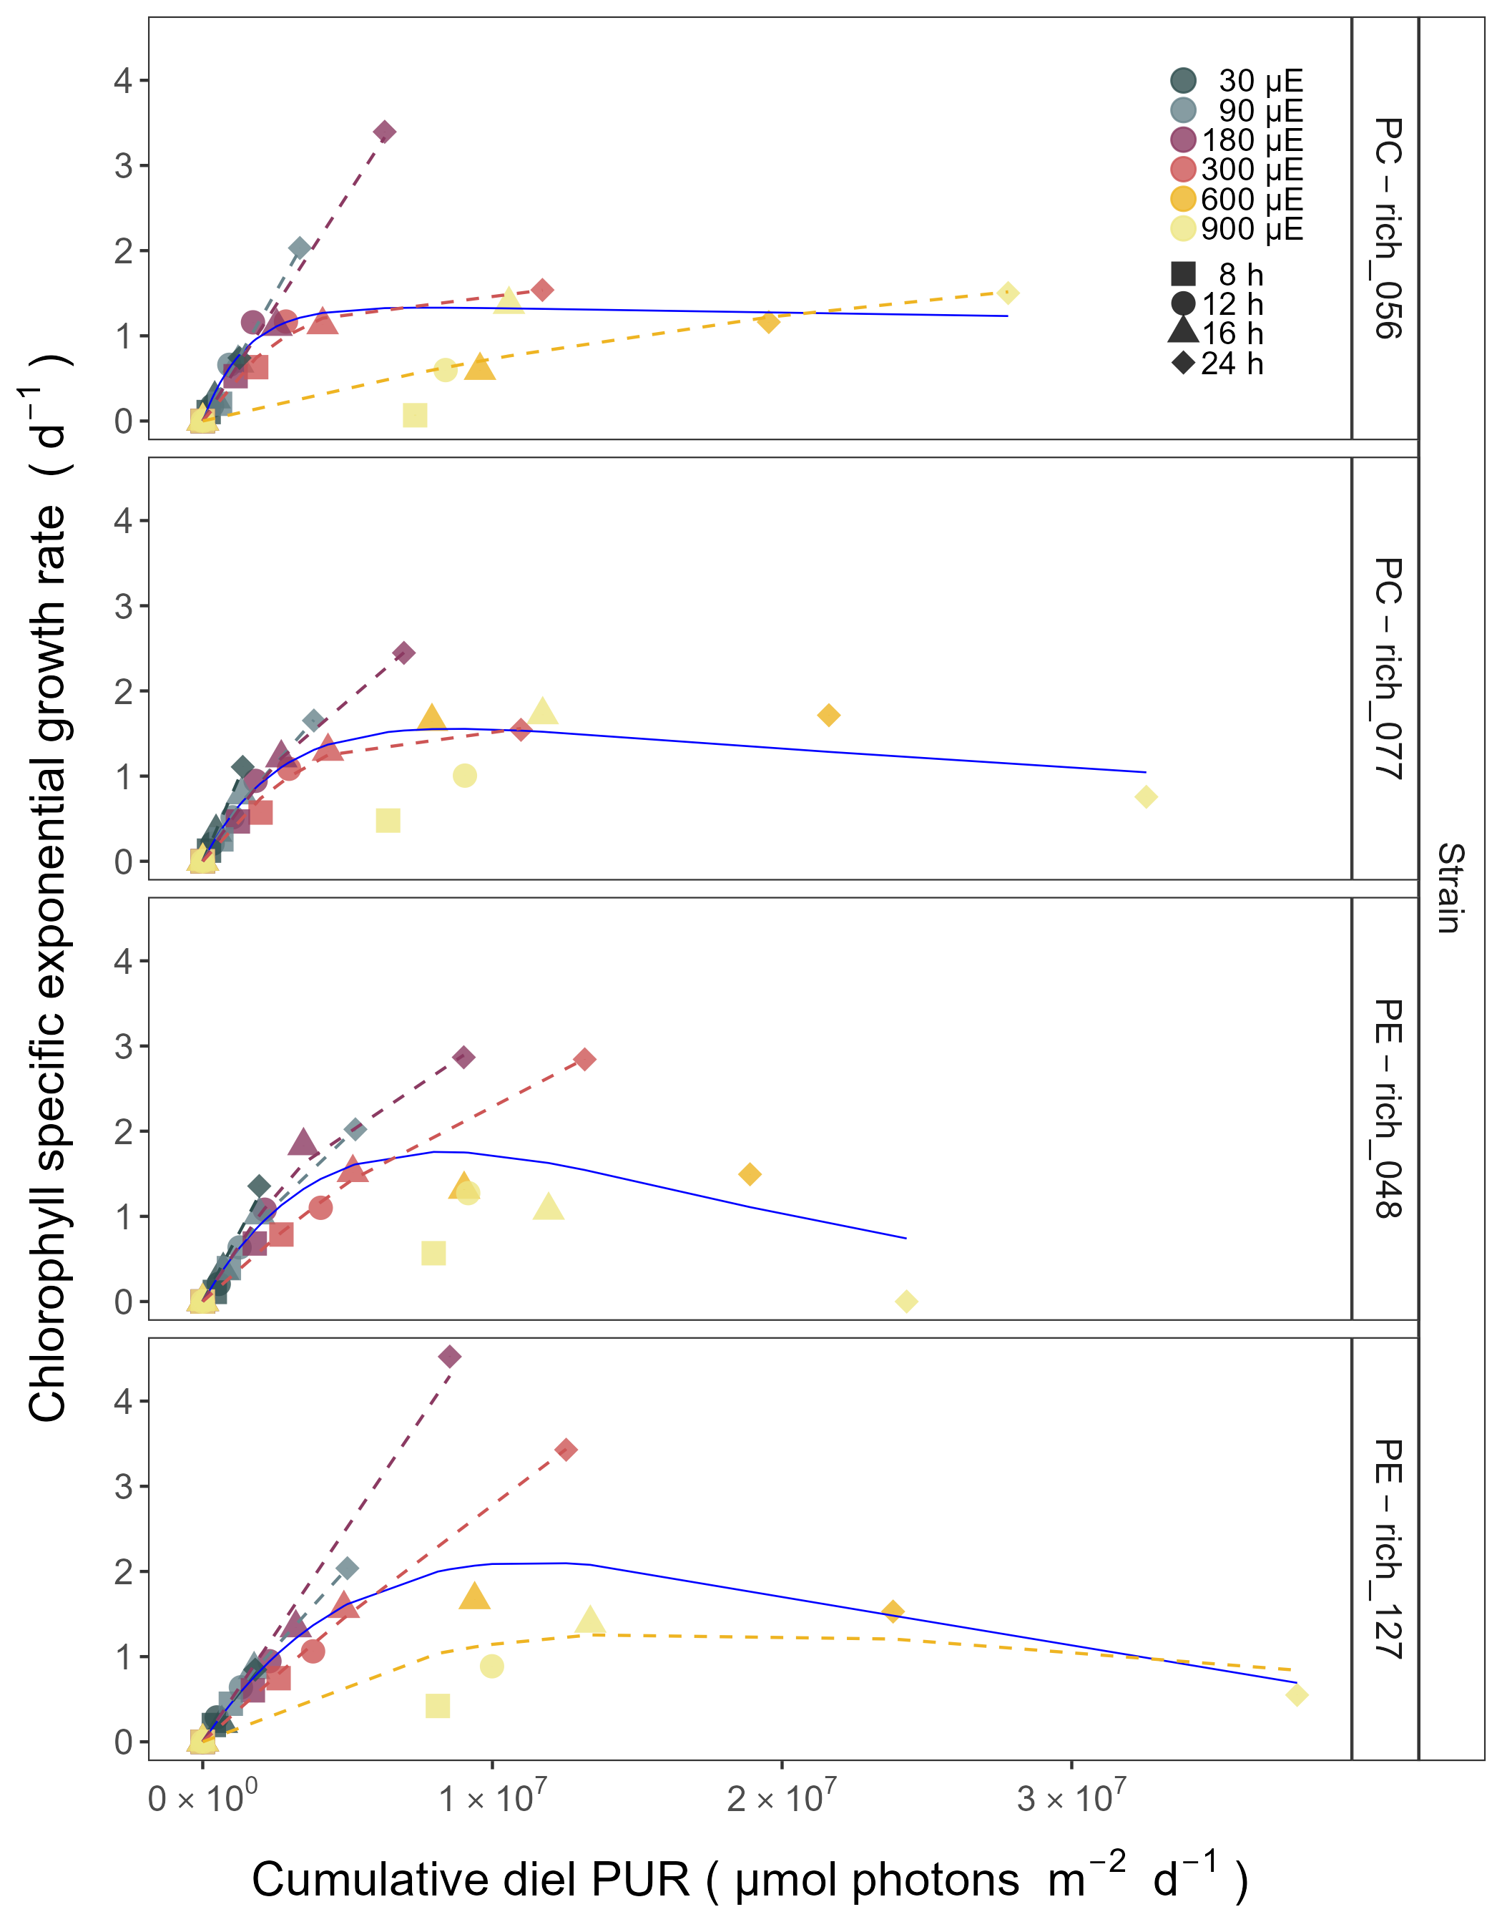

Figure 6: **Chlorophyll specific exponential growth rates (d−1) vs. cumulative diel Photosynthetically Usable Radiation (PUR, µmol photons m−2d−1).** Growth rates (+/- SE falling within symbols) were estimated from logistic fits of chlorophyll proxy OD680-OD720 vs. elapsed time (Fig. 1, S4), for two PhycoCyanin(PC)-rich cultures (056, 077) and two PhycoErythrin(PE)-rich cultures (048, 127) of *Synechococcus* sp. originating from the Baltic Sea. Cultures were grown at 30 (dark gray), 90 (light gray), 180 (purple), 300 (red), 600 (orange), or 900 (yellow) peak PAR µmol photons m−2s−1 (µE); and photoperiods of 8 (square), 12 (circle), 16 (triangle), or 24 (diamond) h. Solid blue line shows a fit of the pooled growth rates for each strain, with a three parameter model (Harrison and Platt, 1986). We also fit the same model separately for 30 (dark gray), 90 (light gray), 180 (purple), 300 (red), 600 together with 900 (orange) peak PAR µmol photons m−2s−1, only when they were each significantly different (ANOVA, *p* < 0.05) from the fit of pooled data.

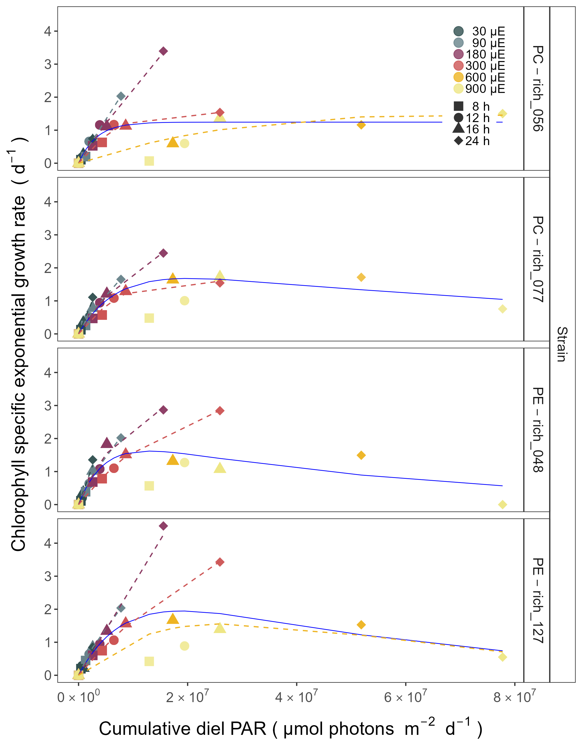

Figure 7: **Chlorophyll specific exponential growth rates (d−1) vs. cumulative diel PAR (µmol photons m−2d−1).** Growth rates (+/- SE falling within symbols) were estimated from logistic fits of chlorophyll proxy OD680-OD720 vs. elapsed time (Fig. S4), for two PhycoCyanin(PC)-rich cultures (056, 077) and two PhycoErythrin(PE)-rich cultures (048, 127) of *Synechococcus* sp. originating from the Baltic Sea. Cultures were grown at 30 (dark gray), 90 (light gray), 180 (purple), 300 (red), 600 (orange), or 900 (yellow) peak PAR µmol photons m−2s−1 (µE); and photoperiods of 8 (square), 12 (circle), 16 (triangle), or 24 (diamond) h. Solid blue line shows a fit of the pooled growth rates for each strain, with a three parameter model (Harrison and Platt, 1986). We also fit the same model separately for 30 (dark gray), 90 (light gray), 180 (purple), 300 (red), 600 together with 900 (orange) peak PAR µmol photons m−2s−1, only when they were each significantly different (ANOVA, *p* < 0.05) from the fit of pooled data.

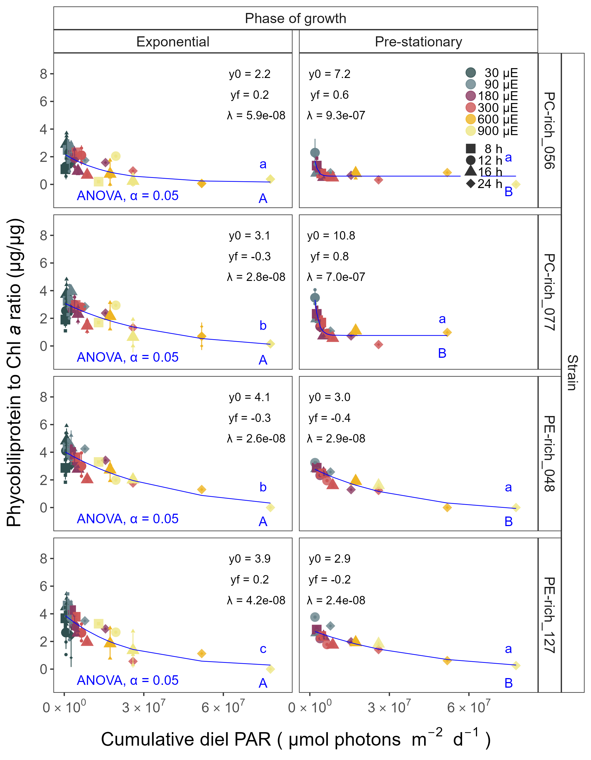

Figure 8: **Changes of Phycobiliprotein to Chl *a* ratio (µg/µg) vs. cumulative diel PAR (µmol photons m−2d−1).** Phycobiliprotein/Chl *a* ratio was estimated for two PhycoCyanin(PC)-rich cultures (056, 077) and two PhycoErythrin(PE)-rich cultures (048, 127) of *Synechococcus* sp. originating from the Baltic Sea. Cultures were grown at 30 (dark gray), 90 (light gray), 180 (purple), 300 (red), 600 (orange), or 900 (yellow) peak PAR µmol photons m−2s−1 (µE); and photoperiods of 8 (square), 12 (circle), 16 (triangle), or 24 (diamond) h. Figure presents data (smaller symbols) and means (bigger symbols) from exponential or pre-stationary phase of growth. Blue solid line shows single phase exponential decay fit for data from each strain and growth phase, fit parameters are presented. Different lowercase letters indicate statistically significant differences between the fit models for different strains within a given phase of growth. Different uppercase letters indicate statistically significant differences between the fit models for different phases of growth within a given strain (ANOVA; *p* < 0.05).

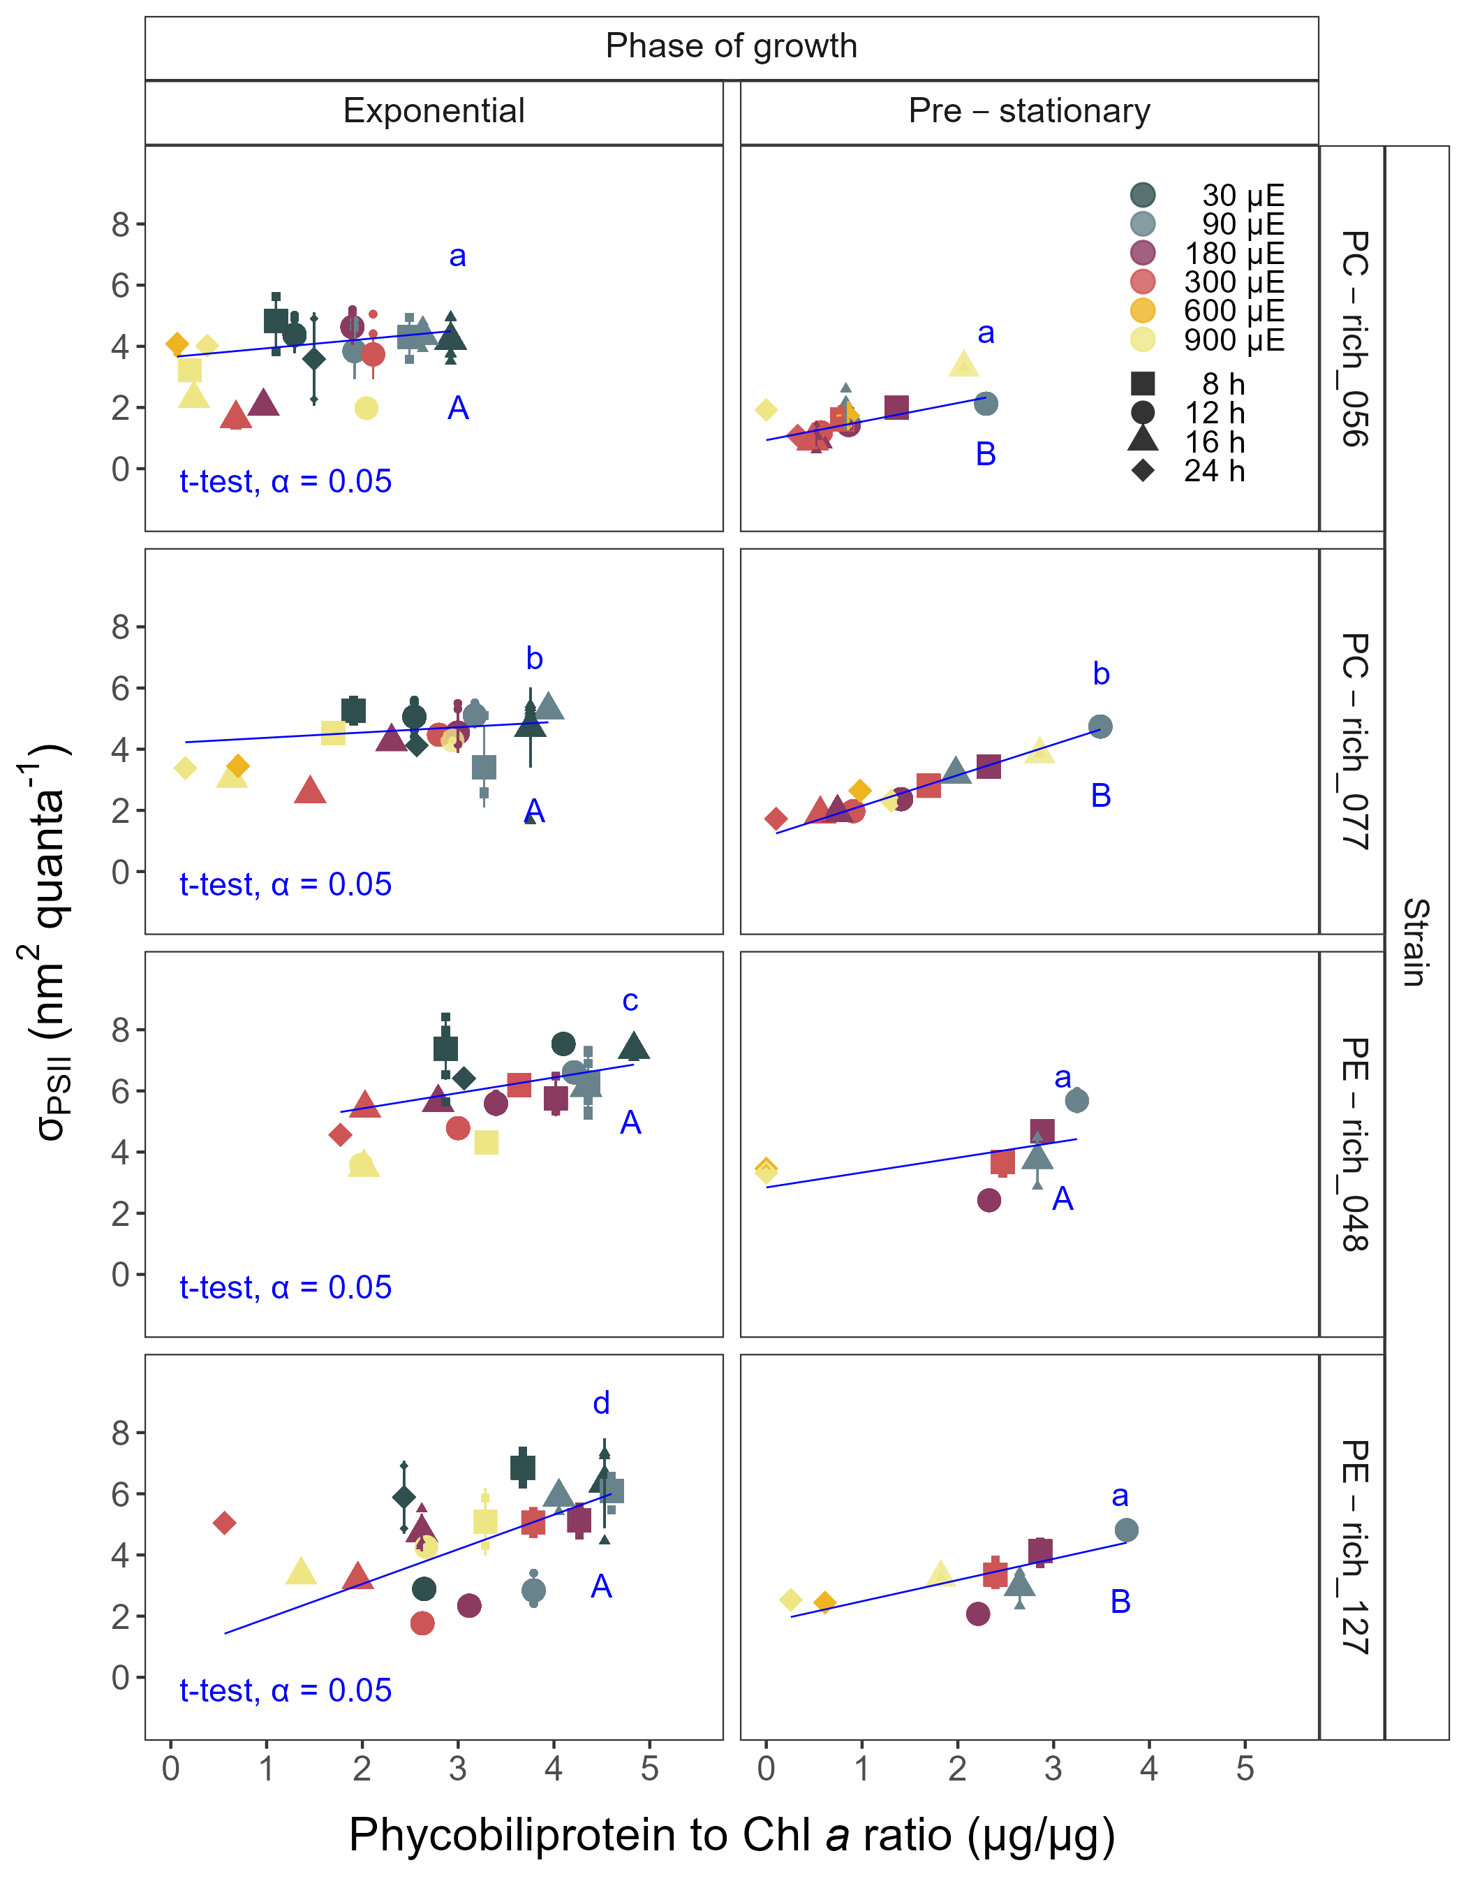

Figure 9: **Changes of effective absorption cross section of PSII** (σPSII; nm2 quanta−1) **measured at the dark period under Ex590 nm (orange) excitation vs. the ratio of sum of µg phycobilins (PE, PC, APC protein, Phycobiliprotein)/µg Chl *a*** Effective absorption cross section of PSII (σPSII; nm2 quanta-1) was estimated for two PhycoCyanin(PC)-rich cultures (056, 077) and two PhycoErythrin(PE)-rich cultures (048, 127) of *Synechococcus* sp. originating from the Baltic Sea. Cultures were grown at 30 (dark gray), 90 (light gray), 180 (purple), 300 (red), 600 (orange), or 900 (yellow) peak PAR µmol photons m−2s−1 (µE); and photoperiods of 8 (square), 12 (circle), 16 (triangle), or 24 (diamond) h. Figure presents data (smaller symbols) and means (bigger symbols) from exponential or pre-stationary phase of growth. Blue solid line shows linear model fit for data from each strain and growth phase. Different lowercase letters indicate statistically significant differences between the fit models for different strains within a given phase of growth. Different uppercase letters indicate statistically significant differences between the fit models for different phases of growth within a given strain (t-test; *p* < 0.05).

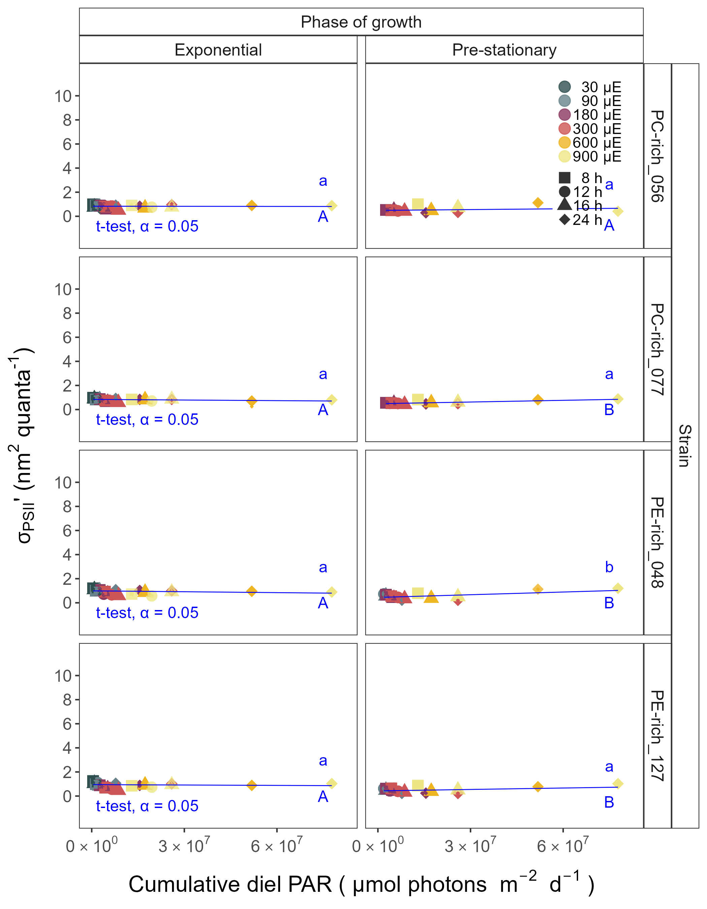

Figure 10: **Effective absorption cross section of PSII** (σPSII‘; nm2 quanta−1) **measured under diel peak PAR growth light under Ex445 nm (blue) excitation vs. cumulative diel PAR (µmol photons m−2d−1).** Effective absorption cross section of PSII (σPSII’; nm2 quanta-1) was estimated for two PhycoCyanin(PC)-rich cultures (056, 077) and two PhycoErythrin(PE)-rich cultures (048, 127) of *Synechococcus* sp. originating from the Baltic Sea. Cultures were grown at 30 (dark gray), 90 (light gray), 180 (purple), 300 (red), 600 (orange), or 900 (yellow) peak PAR µmol photons m−2s−1 (µE); and photoperiods of 8 (square), 12 (circle), 16 (triangle), or 24 (diamond) h. Figure presents data (smaller symbols) and means (bigger symbols) from exponential or pre-stationary phase of growth. Blue solid line shows linear model fit for data from each strain and growth phase. Different lowercase letters indicate statistically significant differences between the fit models for different strains within a given phase of growth. Different uppercase letters indicate statistically significant differences between the fit models for different phases of growth within a given strain (t-test; *p* < 0.05).

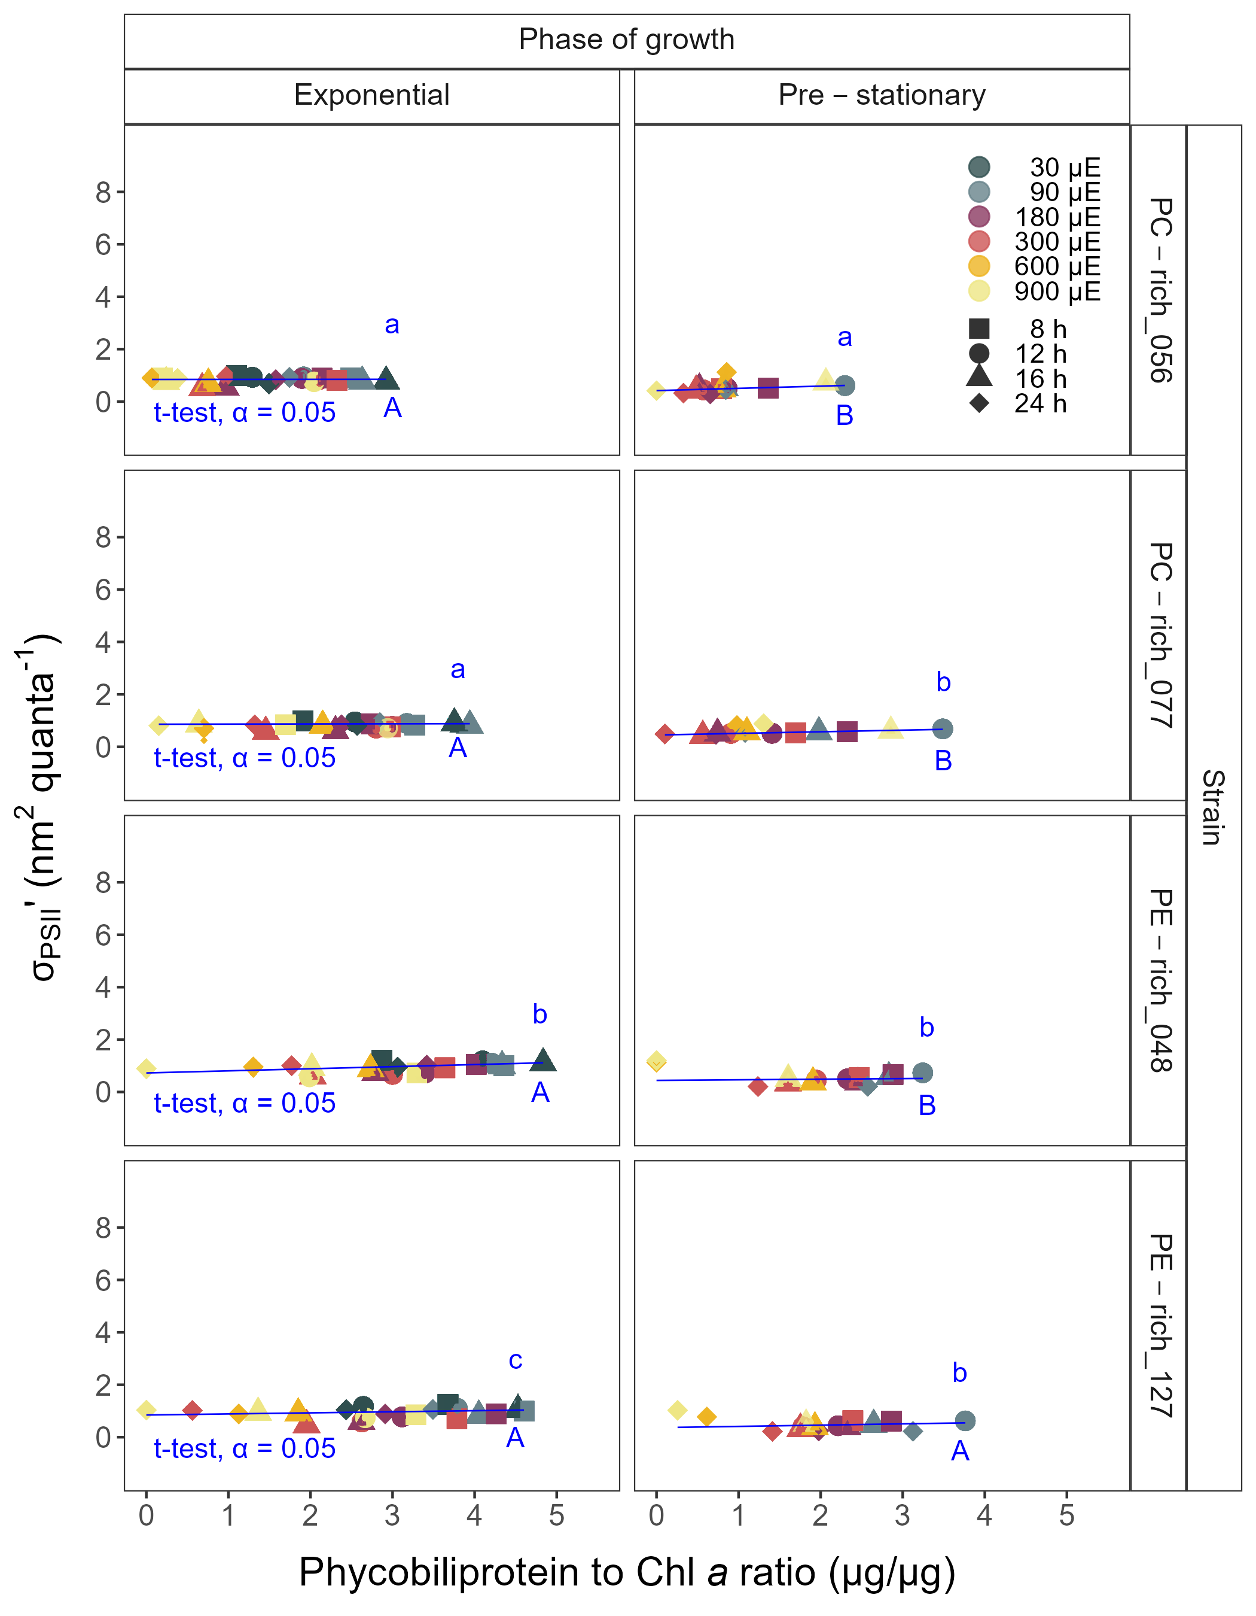

Figure 11: **Changes of effective absorption cross section of PSII** (σPSII‘; nm2 quanta−1) **measured under diel peak PAR growth light under Ex445 nm (blue) excitation vs. the ratio of sum of µg phycobilins (PE, PC, APC protein, Phycobiliprotein)/µg Chl *a*** Effective absorption cross section of PSII (σPSII’; nm2 quanta-1) was estimated for two PhycoCyanin(PC)-rich cultures (056, 077) and two PhycoErythrin(PE)-rich cultures (048, 127) of *Synechococcus* sp. originating from the Baltic Sea. Cultures were grown at 30 (dark gray), 90 (light gray), 180 (purple), 300 (red), 600 (orange), or 900 (yellow) peak PAR µmol photons m−2s−1 (µE); and photoperiods of 8 (square), 12 (circle), 16 (triangle), or 24 (diamond) h. Figure presents data (smaller symbols) and means (bigger symbols) from exponential or pre-stationary phase of growth. Blue solid line shows linear model fit for data from each strain and growth phase. Different lowercase letters indicate statistically significant differences between the fit models for different strains within a given phase of growth. Different uppercase letters indicate statistically significant differences between the fit models for different phases of growth within a given strain (t-test; *p* < 0.05).

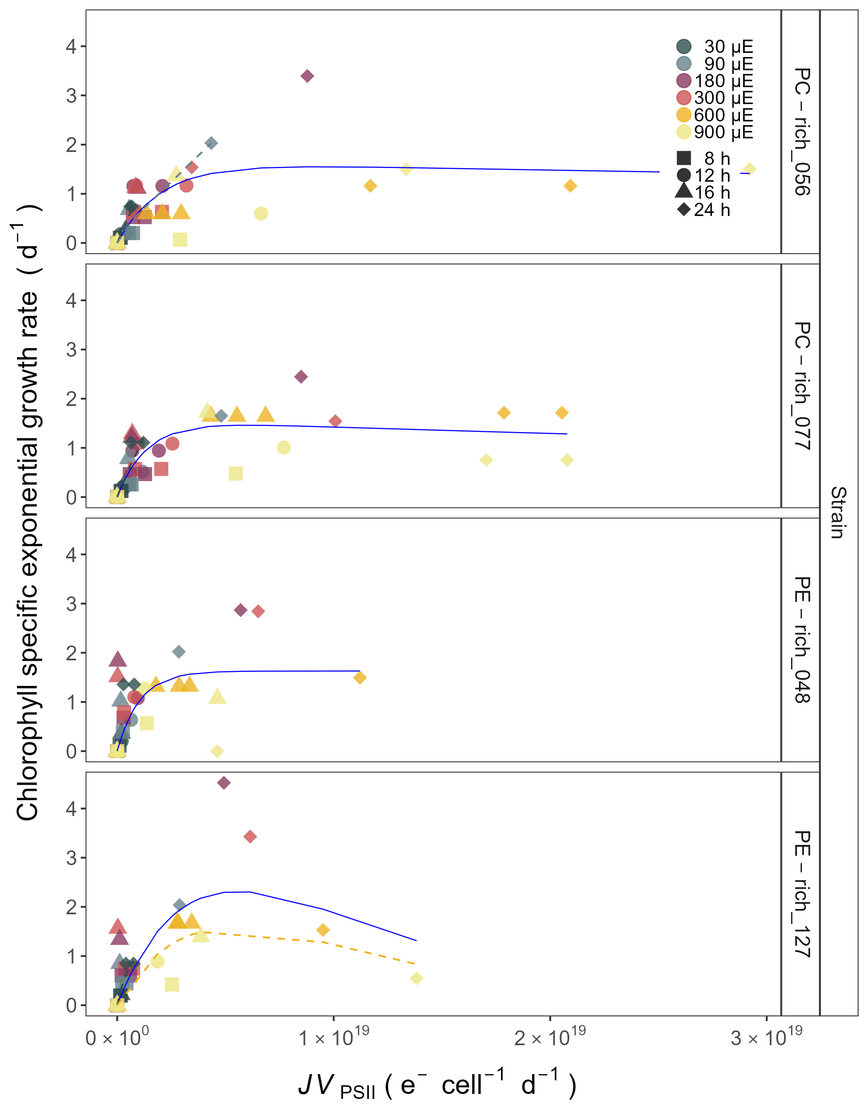

Figure 12: **Chlorophyll specific exponential growth rates (d−1) vs. PSII electron flux (*JV*PSII; e−cell−1d−1) measured under diel peak PAR growth light.** Growth rates (+/- SE falling within symbols) were estimated from logistic fits of chlorophyll proxy OD680 - OD720 vs. elapsed time (Fig. S4). PSII flux (*JV*PSII; e−cell−1d−1) was estimated using FRRf induction curves with excitation of chlorophyll (Ex445nm, blue), for two PhycoCyanin(PC)-rich cultures (056, 077) and two PhycoErythrin(PE)-rich cultures (048, 127) of *Synechococcus* sp. originating from the Baltic Sea. Cultures were grown at 30 (dark gray), 90 (light gray), 180 (purple), 300 (red), 600 (orange), or 900 (yellow) peak PAR µmol photons m−2s−1 (µE); and photoperiods of 8 (square), 12 (circle), 16 (triangle), or 24 (diamond) h. Solid blue line shows a fit of the pooled growth rates for each strain, with a three parameter model (Harrison and Platt 1986). We also fit the same model separately for 30 (dark gray), 90 (light gray), and 600 together with 900 (orange) peak PAR µmol photons m−2s−1, when they were each significantly different (ANOVA, *p* < 0.05) from the fit of pooled data.

Table 1: Linear regression, coefficient of determination (R square), Pearson correlation coefficients (R), and p-value used to calculate the Chl a (µg L-1) of two PhycoCyanin(PC)-rich cultures (056, 077) and two PhycoErythrin(PE)-rich cultures (048, 127) (Culture Collection of Baltic Algae) of Synechococcus sp. based on optical density (DeltaOD) measurements.

| Strain | Linear_regression | R_square | R | p_value |
| --- | --- | --- | --- | --- |
| PC-rich_056 | µg Chl a/L) = (DeltaOD*3822.21)-48.71 | 0.853 | 0.920 | 0.000 |
| PC-rich_077 | µg Chl a/L = (DeltaOD*16779.68)+3.837 | 0.589 | 0.770 | 0.000 |
| PE-rich_048 | µg Chl a/L = (DeltaOD*4328.492)+144.24 | 0.551 | 0.740 | 0.000 |
| PE-rich_127 | µg Chl a/L = (DeltaOD*2805.1)+183.9 | 0.494 | 0.700 | 0.000 |

Table 2: Linear regression, coefficient of determination (R square), Pearson correlation coefficients (R), and p-value used to calculate the number of cells (N mL-1) of two PhycoCyanin(PC)-rich cultures (056, 077) and two PhycoErythrin(PE)-rich cultures (048, 127) (Culture Collection of Baltic Algae) of Synechococcus sp. based on optical density (OD) measurements.

| Strain | OD | Linear_regression | R_square | R | p_value |
| --- | --- | --- | --- | --- | --- |
| PC-rich_056 | 680 | N/mL = (OD680*159866357)+3667252 | 0.534 | 0.730 | 0.000 |
| PC-rich_077 | 680 | N/mL = (OD680*174836861)+27696294 | 0.829 | 0.910 | 0.000 |
| PE-rich_048 | 680 | N/mL = (OD680*195634847)+50753022 | 0.520 | 0.720 | 0.000 |
| PE-rich_127 | 680 | N/mL = (OD680*124907790)+77641680 | 0.424 | 0.650 | 0.000 |
| PC-rich_056 | 720 | N/mL = (OD720*199514099)+5596282 | 0.531 | 0.730 | 0.000 |
| PC-rich_077 | 720 | N/mL = (OD720*214694020)+31010844 | 0.789 | 0.890 | 0.000 |
| PE-rich_048 | 720 | N/mL = (OD720*216637133)+60707950 | 0.451 | 0.670 | 0.000 |
| PE-rich_127 | 720 | N/mL = (OD720*151131397)+79519260 | 0.404 | 0.640 | 0.000 |

Table 3: Linear regression, coefficient of determination (R square), Pearson correlation coefficients (R), and p-value used to calculate the number of cells (N mL-1) of two PhycoCyanin(PC)-rich cultures (056, 077) and two PhycoErythrin(PE)-rich cultures (048, 127) (Culture Collection of Baltic Algae) of Synechococcus sp. based on optical density (OD) measurements.

| Strain | OD | Linear_regression | R_square | R | p_value |
| --- | --- | --- | --- | --- | --- |
| PC-rich_056 | 680 | N/mL = (OD680*160489)+34573 | 0.639 | 0.800 | 0.000 |
| PC-rich_077 | 680 | N/mL = (OD680*204581)+38483 | 0.831 | 0.910 | 0.000 |
| PE-rich_048 | 680 | N/mL = (OD680*450190)+14516 | 0.917 | 0.960 | 0.000 |
| PE-rich_127 | 680 | N/mL = (OD680*614649)+1446 | 0.885 | 0.940 | 0.000 |
| PC-rich_056 | 720 | N/mL = (OD720*218497)+34902 | 0.617 | 0.790 | 0.000 |
| PC-rich_077 | 720 | N/mL = (OD720*264482)+38766 | 0.828 | 0.910 | 0.000 |
| PE-rich_048 | 720 | N/mL = (OD720*600583)+14873 | 0.917 | 0.960 | 0.000 |
| PE-rich_127 | 720 | N/mL = (OD720*803505)+2786 | 0.879 | 0.940 | 0.000 |

Table 4: Linear regression, coefficient of determination (R square), Pearson correlation coefficients (R), and p-value used to calculate the pigment content (µg mL-1) of two PhycoCyanin(PC)-rich cultures (056, 077) and two PhycoErythrin(PE)-rich cultures (048, 127) (Culture Collection of Baltic Algae) of Synechococcus sp. based on absorbance (Abs) measurements.

| Pigment | Abs | Linear_regression | R_square | R | p_value |
| --- | --- | --- | --- | --- | --- |
| Chl a | 665 | Chla µg/mL = (Abs665*13.411029)+0.154793 | 0.865 | 0.930 | 0.000 |
| Car | 480 | Car µg/mL = (Abs480*5.469880)+0.089971 | 0.791 | 0.890 | 0.000 |
| PE | 565 | PE µg/mL = (Abs565*26.760737)-0.143872 | 0.698 | 0.840 | 0.000 |
| PC | 620 | PC µg/mL = (Abs620*29.979866)-0.182611 | 0.807 | 0.900 | 0.000 |
| APC | 650 | APC µg/mL = (Abs650*3.873803)+0.021964 | 0.087 | 0.300 | 0.000 |

Table 5: Three-way factorial ANOVA of chlorophyll specific exponential growth rate (Source_of_variation), estimated from logistic fits of chlorophyll proxy OD680-OD720 vs. elapsed time, for two PhycoCyanin(PC)-rich cultures (056, 077) and two PhycoErythrin(PE)-rich cultures (048, 127) (Culture Collection of Baltic Algae) of Synechococcus sp., grown at 30, 90, 180, 300, 600, or 900 peak PAR µmol photons m−2s−1; and photoperiods of 8, 12, 16, or 24 h. Df – degrees of freedom; Sum Sq – sum of squares; Mean Sq – mean sum of squares; F_value – Fisher's F-test statistic; p_value - level of significance.

| Source_of_variation | Df | Sum Sq | Mean Sq | F_value | p_value |
| --- | --- | --- | --- | --- | --- |
| Par_ue | 5 | 0.049 | 0.010 | 3.276e+30 | 0.000 |
| Photoperiod | 3 | 0.076 | 0.025 | 8.367e+30 | 0.000 |
| Strain | 3 | 0.003 | 0.001 | 3.151e+29 | 0.000 |
| Par_ue:Photoperiod | 13 | 0.040 | 0.003 | 1.025e+30 | 0.000 |
| Par_ue:Strain | 15 | 0.007 | 0.000 | 1.593e+29 | 0.000 |
| Photoperiod:Strain | 9 | 0.004 | 0.000 | 1.306e+29 | 0.000 |
| Par_ue:Photoperiod:Strain | 39 | 0.017 | 0.000 | 1.434e+29 | 0.000 |
| Residuals | 88 | 0.000 | 0.000 | NA | N/A |

Table 6: One-way ANOVA of a three parameter model (Harrison and Platt, 1986) (Fit_model) from pooled data (All) and data fit across different photoperiods (8, 12, 16, or 24) from chlorophyll specific exponential growth rate, for two PhycoCyanin(PC)-rich cultures (056, 077) and two PhycoErythrin(PE)-rich cultures (048, 127) (Culture Collection of Baltic Algae) of Synechococcus sp., grown at 30, 90, 180, 300, 600, or 900 peak PAR µmol photons m−2s−1; and photoperiods of 8, 12, 16, or 24 h. Res.Df - residual degrees of freedom for each model; Res.Sum Sq - residual sum of squares for each model; F_value – Fisher's F-test statistic; p_value - level of significance.

| Strain | Fit_model | Res.Df | Res.Sum Sq | F_value | p_value |
| --- | --- | --- | --- | --- | --- |
| PC-rich_056 | 8_All | 135 | 18.854 | 1.089e+03 | 0.000 |
| PC-rich_056 | 12_All | 135 | 18.854 | 1.412e+01 | 0.000 |
| PC-rich_056 | 16_All | 135 | 18.854 | 7.420e+00 | 0.000 |
| PC-rich_056 | 24_All | 135 | 18.854 | 1.279e+01 | 0.000 |
| PC-rich_077 | 8_All | 131 | 5.672 | 2.749e+01 | 0.000 |
| PC-rich_077 | 12_All | 131 | 5.672 | 8.972e+00 | 0.000 |
| PC-rich_077 | 16_All | 131 | 5.672 | 5.640e+00 | 0.000 |
| PC-rich_077 | 24_All | 131 | 5.672 | 4.027e+00 | 0.000 |
| PE-rich_048 | 8_All | 133 | 16.660 | 2.122e+01 | 0.000 |
| PE-rich_048 | 12_All | 133 | 16.660 | 1.997e+01 | 0.000 |
| PE-rich_048 | 16_All | 133 | 16.660 | 3.576e+00 | 0.000 |
| PE-rich_048 | 24_All | 133 | 16.660 | 8.068e+01 | 0.000 |
| PE-rich_127 | 8_All | 133 | 26.508 | 6.568e+01 | 0.000 |
| PE-rich_127 | 12_All | 133 | 26.508 | 6.758e+03 | 0.000 |
| PE-rich_127 | 16_All | 133 | 26.508 | 1.515e+01 | 0.000 |
| PE-rich_127 | 24_All | 133 | 26.508 | 5.207e+01 | 0.000 |

Table 7: One-way ANOVA of a three parameter model (Harrison and Platt, 1986) (Fit_model) from pooled data (All) and data fit across different peak PAR (30, 90, 180, 300, 600 together with 900) from chlorophyll specific exponential growth rate, for two PhycoCyanin(PC)-rich cultures (056, 077) and two PhycoErythrin(PE)-rich cultures (048, 127) (Culture Collection of Baltic Algae) of Synechococcus sp., grown at 30, 90, 180, 300, 600, or 900 peak PAR µmol photons m−2s−1; and photoperiods of 8, 12, 16, or 24 h. Res.Df - residual degrees of freedom for each model; Res.Sum Sq - residual sum of squares for each model; F_value – Fisher's F-test statistic; p_value - level of significance.

| Strain | Fit_model | Res.Df | Res.Sum Sq | F_value | p_value |
| --- | --- | --- | --- | --- | --- |
| PC-rich_056 | 30_All | 135 | 18.854 | 1.089e+03 | 0.000 |
| PC-rich_056 | 90_All | 135 | 18.854 | 1.412e+01 | 0.000 |
| PC-rich_056 | 180_All | 135 | 18.854 | 7.420e+00 | 0.000 |
| PC-rich_056 | 300_All | 135 | 18.854 | 1.279e+01 | 0.000 |
| PC-rich_056 | 900_All | 135 | 18.854 | 2.573e+00 | 0.003 |
| PC-rich_077 | 30_All | 131 | 5.672 | 2.749e+01 | 0.000 |
| PC-rich_077 | 90_All | 131 | 5.672 | 8.972e+00 | 0.000 |
| PC-rich_077 | 180_All | 131 | 5.672 | 5.640e+00 | 0.000 |
| PC-rich_077 | 300_All | 131 | 5.672 | 4.027e+00 | 0.000 |
| PC-rich_077 | 900_All | 131 | 5.672 | 7.428e-01 | 0.844 |
| PE-rich_048 | 30_All | 133 | 16.660 | 2.122e+01 | 0.000 |
| PE-rich_048 | 90_All | 133 | 16.660 | 1.997e+01 | 0.000 |
| PE-rich_048 | 180_All | 133 | 16.660 | 3.576e+00 | 0.000 |
| PE-rich_048 | 300_All | 133 | 16.660 | 8.068e+01 | 0.000 |
| PE-rich_048 | 900_All | 133 | 16.660 | 1.893e+00 | 0.034 |
| PE-rich_127 | 30_All | 133 | 26.508 | 6.568e+01 | 0.000 |
| PE-rich_127 | 90_All | 133 | 26.508 | 6.758e+03 | 0.000 |
| PE-rich_127 | 180_All | 133 | 26.508 | 1.515e+01 | 0.000 |
| PE-rich_127 | 300_All | 133 | 26.508 | 5.207e+01 | 0.000 |
| PE-rich_127 | 900_All | 133 | 26.508 | 2.800e+00 | 0.002 |

Table 8: Three-way factorial ANOVA of PUR/PAR ratio (Source_of_variation), for two PhycoCyanin(PC)-rich cultures (056, 077) and two PhycoErythrin(PE)-rich cultures (048, 127) (Culture Collection of Baltic Algae) of Synechococcus sp., grown at 30, 90, 180, 300, 600, or 900 peak PAR µmol photons m−2s−1; and photoperiods of 8, 12, 16, or 24 h. Df – degrees of freedom; Sum Sq – sum of squares; Mean Sq – mean sum of squares; F_value – Fisher's F-test statistic; p_value - level of significance.

| Source_of_variation | Df | Sum Sq | Mean Sq | F_value | p_value |
| --- | --- | --- | --- | --- | --- |
| PhotonDose_day | 18 | 1.901 | 0.106 | 4.157e+01 | 0.000 |
| Phase | 1 | 0.334 | 0.334 | 1.314e+02 | 0.000 |
| Strain | 3 | 1.991 | 0.664 | 2.614e+02 | 0.000 |
| PhotonDose_day:Phase | 12 | 0.036 | 0.003 | 1.175e+00 | 0.305 |
| PhotonDose_day:Strain | 52 | 0.623 | 0.012 | 4.720e+00 | 0.000 |
| Phase:Strain | 3 | 0.028 | 0.009 | 3.723e+00 | 0.013 |
| PhotonDose_day:Phase:Strain | 13 | 0.016 | 0.001 | 4.994e-01 | 0.922 |
| Residuals | 159 | 0.404 | 0.003 | NA | N/A |

Table 9: One-way ANOVA of single phase exponential decay fit model (Fit_model) of pooled data across different strains for a given phase of growth (exponential; _Exp, pre-stationary; _St) and across different phase of growth for a given strain (_Exp_St) from PUR/PAR ratio, for two PhycoCyanin(PC)-rich cultures (056, 077) and two PhycoErythrin(PE)-rich cultures (048, 127) (Culture Collection of Baltic Algae) of Synechococcus sp., grown at 30, 90, 180, 300, 600, or 900 peak PAR µmol photons m−2s−1; and photoperiods of 8, 12, 16, or 24 h. Res.Df - residual degrees of freedom for each model; Res.Sum Sq - residual sum of squares for each model; F_value – Fisher's F-test statistic; p_value - level of significance.

| Fit_model | Res.Df | Res.Sum Sq | F_value | p_value |
| --- | --- | --- | --- | --- |
| 056_077_Exp | 43 | 0.025 | 2.813e+01 | 0.000 |
| 048_127_Exp | 51 | 0.217 | NA | N/A |
| 056_048_Exp | 51 | 0.307 | 2.762e+01 | 0.000 |
| 077_048_Exp | 51 | 0.307 | 5.976e+01 | 0.000 |
| 056_127_Exp | 51 | 0.217 | 1.607e+01 | 0.000 |
| 077_127_Exp | 51 | 0.217 | 4.064e+01 | 0.000 |
| 056_077_St | 20 | 0.006 | -1.491e-01 | 1.000 |
| 048_127_St | 2 | 0.000 | 5.386e+00 | 0.168 |
| 056_048_St | 17 | 0.009 | 9.648e-02 | 0.999 |
| 077_048_St | 17 | 0.009 | -2.066e+00 | 1.000 |
| 056_127_St | 2 | 0.000 | 1.415e+01 | 0.067 |
| 077_127_St | 2 | 0.000 | 2.812e+00 | 0.294 |
| 056_Exp_St | 7 | 0.008 | 1.882e+00 | 0.195 |
| 077_Exp_St | 20 | 0.006 | 3.039e+00 | 0.007 |
| 048_Exp_St | 17 | 0.009 | 1.681e+01 | 0.000 |
| 127_Exp_St | 2 | 0.000 | 4.128e+01 | 0.024 |

Table 10: Three-way factorial ANOVA of total Phyco/Chl a ratio (Source_of_variation), for two PhycoCyanin(PC)-rich cultures (056, 077) and two PhycoErythrin(PE)-rich cultures (048, 127) (Culture Collection of Baltic Algae) of Synechococcus sp., grown at 30, 90, 180, 300, 600, or 900 peak PAR µmol photons m−2s−1; and photoperiods of 8, 12, 16, or 24 h. Df – degrees of freedom; Sum Sq – sum of squares; Mean Sq – mean sum of squares; F_value – Fisher's F-test statistic; p_value - level of significance.

| Source_of_variation | Df | Sum Sq | Mean Sq | F_value | p_value |
| --- | --- | --- | --- | --- | --- |
| PhotonDose_day | 18 | 262.901 | 14.606 | 2.885e+01 | 0.000 |
| Phase | 1 | 36.951 | 36.951 | 7.299e+01 | 0.000 |
| Strain | 3 | 126.558 | 42.186 | 8.332e+01 | 0.000 |
| PhotonDose_day:Phase | 12 | 9.647 | 0.804 | 1.588e+00 | 0.098 |
| PhotonDose_day:Strain | 54 | 27.834 | 0.515 | 1.018e+00 | 0.451 |
| Phase:Strain | 3 | 2.600 | 0.867 | 1.712e+00 | 0.166 |
| PhotonDose_day:Phase:Strain | 35 | 6.101 | 0.174 | 3.443e-01 | 1.000 |
| Residuals | 185 | 93.662 | 0.506 | NA | N/A |

Table 11: One-way ANOVA of single phase exponential decay fit model (Fit_model) of pooled data across different strains for a given phase of growth (exponential; _Exp, pre-stationary; _St) and across different phase of growth for a given strain (_Exp_St) from total Phyco/Chl a ratio, for two PhycoCyanin(PC)-rich cultures (056, 077) and two PhycoErythrin(PE)-rich cultures (048, 127) (Culture Collection of Baltic Algae) of Synechococcus sp., grown at 30, 90, 180, 300, 600, or 900 peak PAR µmol photons m−2s−1; and photoperiods of 8, 12, 16, or 24 h. Res.Df - residual degrees of freedom for each model; Res.Sum Sq - residual sum of squares for each model; F_value – Fisher's F-test statistic; p_value - level of significance.

| Fit_model | Res.Df | Res.Sum Sq | F_value | p_value |
| --- | --- | --- | --- | --- |
| 056_077_Exp | 49 | 38.089 | 1.531e+01 | 0.000 |
| 048_127_Exp | 52 | 54.559 | NA | N/A |
| 056_048_Exp | 52 | 39.302 | 4.333e+00 | 0.005 |
| 077_048_Exp | 52 | 39.302 | 5.202e-01 | 0.670 |
| 056_127_Exp | 52 | 54.559 | 1.067e+01 | 0.000 |
| 077_127_Exp | 52 | 54.559 | 7.063e+00 | 0.000 |
| 056_077_St | 24 | 3.580 | -1.005e+01 | 1.000 |
| 048_127_St | 19 | 3.343 | NA | N/A |
| 056_048_St | 19 | 2.239 | -2.229e-01 | 1.000 |
| 077_048_St | 19 | 2.239 | 2.276e+00 | 0.088 |
| 056_127_St | 19 | 3.343 | -1.195e+00 | 1.000 |
| 077_127_St | 19 | 3.343 | 2.686e-01 | 0.925 |
| 056_Exp_St | 25 | 2.081 | 1.399e+01 | 0.000 |
| 077_Exp_St | 24 | 3.580 | 9.255e+00 | 0.000 |
| 048_Exp_St | 19 | 2.239 | 9.531e+00 | 0.000 |
| 127_Exp_St | 19 | 3.343 | 8.820e+00 | 0.000 |

Table 12: Three-way factorial ANOVA of effective absorption cross section of PSII (σPSII’; nm2 quanta-1) measured under diel peak PAR growth light under Ex445 nm (blue) excitation (Source_of_variation), for two PhycoCyanin(PC)-rich cultures (056, 077) and two PhycoErythrin(PE)-rich cultures (048, 127) (Culture Collection of Baltic Algae) of Synechococcus sp., grown at 30, 90, 180, 300, 600, or 900 peak PAR µmol photons m−2s−1; and photoperiods of 8, 12, 16, or 24 h. Df – degrees of freedom; Sum Sq – sum of squares; Mean Sq – mean sum of squares; F_value – Fisher's F-test statistic; p_value - level of significance.

| Source_of_variation | Df | Sum Sq | Mean Sq | F_value | p_value |
| --- | --- | --- | --- | --- | --- |
| PhotonDose_day | 18 | 31.956 | 1.775 | 2.140e+02 | 0.000 |
| Phase | 1 | 15.718 | 15.718 | 1.894e+03 | 0.000 |
| Strain | 3 | 1.086 | 0.362 | 4.361e+01 | 0.000 |
| PhotonDose_day:Phase | 13 | 5.727 | 0.441 | 5.309e+01 | 0.000 |
| PhotonDose_day:Strain | 54 | 4.330 | 0.080 | 9.663e+00 | 0.000 |
| Phase:Strain | 3 | 0.296 | 0.099 | 1.189e+01 | 0.000 |
| PhotonDose_day:Phase:Strain | 34 | 1.710 | 0.050 | 6.063e+00 | 0.000 |
| Residuals | 856 | 7.103 | 0.008 | NA | N/A |

Table 13: T-test of linear fit model (Fit_model) of pooled data across different strains for a given phase of growth (exponential; _Exp, pre-stationary; _St) and across different phase of growth for a given strain (_Exp_St) from effective absorption cross section of PSII (σPSII’; nm2 quanta-1) measured under diel peak PAR growth light under Ex445 nm (blue) excitation, for two PhycoCyanin(PC)-rich cultures (056, 077) and two PhycoErythrin(PE)-rich cultures (048, 127) (Culture Collection of Baltic Algae) of Synechococcus sp., grown at 30, 90, 180, 300, 600, or 900 peak PAR µmol photons m−2s−1; and photoperiods of 8, 12, 16, or 24 h. Estimate - estimation statistics; Std.Error - standard error of the estimate; t_value – t-test statistic; p_value - level of significance.

| Fit_model | Estimate | Std.Error | t_value | p_value |
| --- | --- | --- | --- | --- |
| 056_077_Exp | -1.451e-09 | 1.058e-09 | -1.372 | 0.171 |
| 056_048_Exp | -2.188e-09 | 1.313e-09 | -1.666 | 0.097 |
| 056_127_Exp | -8.236e-10 | 1.412e-09 | -0.583 | 0.560 |
| 048_127_Exp | 1.365e-09 | 1.603e-09 | 0.851 | 0.395 |
| 077_048_Exp | -7.373e-10 | 1.233e-09 | -0.598 | 0.550 |
| 077_127_Exp | 6.274e-10 | 1.336e-09 | 0.470 | 0.639 |
| 056_077_St | 2.453e-09 | 1.349e-09 | 1.818 | 0.071 |
| 056_048_St | 5.254e-09 | 2.098e-09 | 2.505 | 0.014 |
| 056_127_St | 1.745e-09 | 1.862e-09 | 0.937 | 0.350 |
| 048_127_St | -3.509e-09 | 1.658e-09 | -2.116 | 0.036 |
| 077_048_St | 2.801e-09 | 1.263e-09 | 2.217 | 0.028 |
| 077_127_St | -7.077e-10 | 1.209e-09 | -0.586 | 0.559 |
| 056_Exp_St | 2.487e-09 | 1.643e-09 | 1.514 | 0.132 |
| 077_Exp_St | 6.391e-09 | 9.166e-10 | 6.973 | 0.000 |
| 048_Exp_St | 9.930e-09 | 1.695e-09 | 5.860 | 0.000 |
| 127_Exp_St | 5.056e-09 | 1.621e-09 | 3.120 | 0.002 |

Table 14: Three-way factorial ANOVA of effective absorption cross section of PSII (σPSII’; nm2 quanta-1) measured under diel peak PAR growth light under Ex590 nm (orange) excitation (Source_of_variation), for two PhycoCyanin(PC)-rich cultures (056, 077) and two PhycoErythrin(PE)-rich cultures (048, 127) (Culture Collection of Baltic Algae) of Synechococcus sp., grown at 30, 90, 180, 300, 600, or 900 peak PAR µmol photons m−2s−1; and photoperiods of 8, 12, 16, or 24 h. Df – degrees of freedom; Sum Sq – sum of squares; Mean Sq – mean sum of squares; F_value – Fisher's F-test statistic; p_value - level of significance.

| Source_of_variation | Df | Sum Sq | Mean Sq | F_value | p_value |
| --- | --- | --- | --- | --- | --- |
| PhotonDose_day | 15 | 1,101.207 | 73.414 | 1.351e+02 | 0.000 |
| Phase | 1 | 177.130 | 177.130 | 3.259e+02 | 0.000 |
| Strain | 3 | 445.771 | 148.590 | 2.734e+02 | 0.000 |
| PhotonDose_day:Phase | 12 | 81.052 | 6.754 | 1.243e+01 | 0.000 |
| PhotonDose_day:Strain | 43 | 137.289 | 3.193 | 5.874e+00 | 0.000 |
| Phase:Strain | 3 | 29.057 | 9.686 | 1.782e+01 | 0.000 |
| PhotonDose_day:Phase:Strain | 12 | 17.653 | 1.471 | 2.707e+00 | 0.002 |
| Residuals | 446 | 242.409 | 0.544 | NA | N/A |

Table 15: One-way ANOVA of single phase exponential decay fit model (Fit_model) of pooled data across different strains for a given phase of growth (exponential; _Exp, pre-stationary; _St) and across different phase of growth for a given strain (_Exp_St) from effective absorption cross section of PSII (σPSII’; nm2 quanta-1) measured under diel peak PAR growth light under Ex590 nm (orange) excitation, for two PhycoCyanin(PC)-rich cultures (056, 077) and two PhycoErythrin(PE)-rich cultures (048, 127) (Culture Collection of Baltic Algae) of Synechococcus sp., grown at 30, 90, 180, 300, 600, or 900 peak PAR µmol photons m−2s−1; and photoperiods of 8, 12, 16, or 24 h. Res.Df - residual degrees of freedom for each model; Res.Sum Sq - residual sum of squares for each model; F_value – Fisher's F-test statistic; p_value - level of significance.

| Fit_model | Res.Df | Res.Sum Sq | F_value | p_value |
| --- | --- | --- | --- | --- |
| 056_077_Exp | 97 | 116.359 | 9.926e-01 | 0.469 |
| 048_127_Exp | 72 | 106.728 | -1.652e+00 | 1.000 |
| 056_048_Exp | 97 | 116.359 | 3.764e+01 | 0.000 |
| 077_048_Exp | 112 | 134.219 | 8.037e+00 | 0.000 |
| 056_127_Exp | 72 | 106.728 | 2.599e-01 | 1.000 |
| 077_127_Exp | 72 | 106.728 | 4.636e-01 | 0.995 |
| 056_077_St | 41 | 3.366 | 1.522e+01 | 0.000 |
| 048_127_St | 45 | 38.775 | 3.762e+00 | 0.001 |
| 056_048_St | 34 | 17.489 | 1.158e+02 | 0.000 |
| 077_048_St | 34 | 17.489 | -3.922e+00 | 1.000 |
| 056_127_St | 45 | 38.775 | 1.566e+02 | 0.000 |
| 077_127_St | 45 | 38.775 | 1.078e+02 | 0.000 |
| 056_Exp_St | 17 | 0.150 | 1.650e+02 | 0.000 |
| 077_Exp_St | 41 | 3.366 | 2.245e+01 | 0.000 |
| 048_Exp_St | 34 | 17.489 | 1.146e+00 | 0.339 |
| 127_Exp_St | 45 | 38.775 | 2.921e+00 | 0.001 |

Table 16: Three-way factorial ANOVA of effective absorption cross section of PSII (σPSII’; nm2 quanta-1) measured under diel peak PAR growth light under Ex445 nm (blue) excitation in relation to the total Phyco/Chl a ratio (Source_of_variation), for two PhycoCyanin(PC)-rich cultures (056, 077) and two PhycoErythrin(PE)-rich cultures (048, 127) (Culture Collection of Baltic Algae) of Synechococcus sp., grown at 30, 90, 180, 300, 600, or 900 peak PAR µmol photons m−2s−1; and photoperiods of 8, 12, 16, or 24 h. Df – degrees of freedom; Sum Sq – sum of squares; Mean Sq – mean sum of squares; F_value – Fisher's F-test statistic; p_value - level of significance.

| Source_of_variation | Df | Sum Sq | Mean Sq | F_value | p_value |
| --- | --- | --- | --- | --- | --- |
| PhotonDose_day | 1 | 101.432 | 101.432 | 3.585e+03 | 0.000 |
| Phase | 1 | 115.426 | 115.426 | 4.080e+03 | 0.000 |
| Strain | 3 | 2.958 | 0.986 | 3.486e+01 | 0.000 |
| PhotonDose_day:Phase | 1 | 0.946 | 0.946 | 3.343e+01 | 0.000 |
| PhotonDose_day:Strain | 3 | 5.317 | 1.772 | 6.265e+01 | 0.000 |
| Phase:Strain | 3 | 4.282 | 1.427 | 5.046e+01 | 0.000 |
| PhotonDose_day:Phase:Strain | 3 | 1.404 | 0.468 | 1.655e+01 | 0.000 |
| Residuals | 6057 | 171.359 | 0.028 | NA | N/A |

Table 17: T-test of linear fit model (Fit_model) of pooled data across different strains for a given phase of growth (exponential; _Exp, pre-stationary; _St) and across different phase of growth for a given strain (_Exp_St) from effective absorption cross section of PSII (σPSII’; nm2 quanta-1) measured under diel peak PAR growth light under Ex445 nm (blue) excitation in relation to the total Phyco/Chl a ratio, for two PhycoCyanin(PC)-rich cultures (056, 077) and two PhycoErythrin(PE)-rich cultures (048, 127) (Culture Collection of Baltic Algae) of Synechococcus sp., grown at 30, 90, 180, 300, 600, or 900 peak PAR µmol photons m−2s−1; and photoperiods of 8, 12, 16, or 24 h. Estimate - estimation statistics; Std.Error - standard error of the estimate; t_value – t-test statistic; p_value - level of significance.

| Fit_model | Estimate | Std.Error | t_value | p_value |
| --- | --- | --- | --- | --- |
| 056_077_Exp | 0.003 | 0.008 | 0.424 | 0.672 |
| 056_048_Exp | 0.078 | 0.009 | 9.082 | 0.000 |
| 056_127_Exp | 0.039 | 0.009 | 4.382 | 0.000 |
| 048_127_Exp | -0.039 | 0.009 | -4.416 | 0.000 |
| 077_048_Exp | 0.075 | 0.008 | 8.954 | 0.000 |
| 077_127_Exp | 0.036 | 0.009 | 4.117 | 0.000 |
| 056_077_St | -0.023 | 0.007 | -3.495 | 0.000 |
| 056_048_St | -0.062 | 0.016 | -3.788 | 0.000 |
| 056_127_St | -0.037 | 0.014 | -2.606 | 0.009 |
| 048_127_St | 0.026 | 0.023 | 1.143 | 0.253 |
| 077_048_St | -0.039 | 0.014 | -2.823 | 0.005 |
| 077_127_St | -0.013 | 0.012 | -1.117 | 0.264 |
| 056_Exp_St | 0.083 | 0.013 | 6.327 | 0.000 |
| 077_Exp_St | 0.057 | 0.009 | 6.590 | 0.000 |
| 048_Exp_St | -0.057 | 0.018 | -3.217 | 0.001 |
| 127_Exp_St | 0.008 | 0.020 | 0.389 | 0.698 |

Table 18: Three-way factorial ANOVA of effective absorption cross section of PSII (σPSII’; nm2 quanta-1) measured under diel peak PAR growth light under Ex590 nm (orange) excitation in relation to the total Phyco/Chl a ratio, for two PhycoCyanin(PC)-rich cultures (056, 077) and two PhycoErythrin(PE)-rich cultures (048, 127) (Culture Collection of Baltic Algae) of Synechococcus sp., grown at 30, 90, 180, 300, 600, or 900 peak PAR µmol photons m−2s−1; and photoperiods of 8, 12, 16, or 24 h. Df – degrees of freedom; Sum Sq – sum of squares; Mean Sq – mean sum of squares; F_value – Fisher's F-test statistic; p_value - level of significance.

| Source_of_variation | Df | Sum Sq | Mean Sq | F_value | p_value |
| --- | --- | --- | --- | --- | --- |
| PhotonDose_day | 1 | 6,544.058 | 6,544.058 | 3.448e+03 | 0.000 |
| Phase | 1 | 2,258.458 | 2,258.458 | 1.190e+03 | 0.000 |
| Strain | 3 | 2,055.696 | 685.232 | 3.610e+02 | 0.000 |
| PhotonDose_day:Phase | 1 | 337.724 | 337.724 | 1.779e+02 | 0.000 |
| PhotonDose_day:Strain | 3 | 423.482 | 141.161 | 7.437e+01 | 0.000 |
| Phase:Strain | 3 | 475.763 | 158.588 | 8.355e+01 | 0.000 |
| PhotonDose_day:Phase:Strain | 3 | 119.816 | 39.939 | 2.104e+01 | 0.000 |
| Residuals | 4254 | 8,074.929 | 1.898 | NA | N/A |

Table 19: T-test of linear fit model (Fit_model) of pooled data across different strains for a given phase of growth (exponential; _Exp, pre-stationary; _St) and across different phase of growth for a given strain (_Exp_St) from effective absorption cross section of PSII (σPSII’; nm2 quanta-1) measured under diel peak PAR growth light under Ex590 nm (orange) excitation in relation to the total Phyco/Chl a ratio, for two PhycoCyanin(PC)-rich cultures (056, 077) and two PhycoErythrin(PE)-rich cultures (048, 127) (Culture Collection of Baltic Algae) of Synechococcus sp., grown at 30, 90, 180, 300, 600, or 900 peak PAR µmol photons m−2s−1; and photoperiods of 8, 12, 16, or 24 h. Estimate - estimation statistics; Std.Error - standard error of the estimate; t_value – t-test statistic; p_value - level of significance.

| Fit_model | Estimate | Std.Error | t_value | p_value |
| --- | --- | --- | --- | --- |
| 056_077_Exp | -0.369 | 0.092 | -4.000 | 0.000 |
| 056_048_Exp | 0.149 | 0.082 | 1.812 | 0.070 |
| 056_127_Exp | 0.606 | 0.099 | 6.122 | 0.000 |
| 048_127_Exp | 0.457 | 0.090 | 5.084 | 0.000 |
| 077_048_Exp | 0.518 | 0.083 | 6.267 | 0.000 |
| 077_127_Exp | 0.976 | 0.097 | 10.089 | 0.000 |
| 056_077_St | 0.077 | 0.029 | 2.669 | 0.008 |
| 056_048_St | -0.610 | 0.079 | -7.751 | 0.000 |
| 056_127_St | -0.299 | 0.071 | -4.191 | 0.000 |
| 048_127_St | 0.311 | 0.177 | 1.759 | 0.080 |
| 077_048_St | -0.688 | 0.076 | -9.099 | 0.000 |
| 077_127_St | -0.377 | 0.070 | -5.371 | 0.000 |
| 056_Exp_St | 0.440 | 0.117 | 3.761 | 0.000 |
| 077_Exp_St | 0.887 | 0.091 | 9.780 | 0.000 |
| 048_Exp_St | -0.319 | 0.148 | -2.164 | 0.031 |
| 127_Exp_St | -0.465 | 0.247 | -1.882 | 0.060 |